Chapter 12, Problem 67.

As shown in Fig. 12.72, a three-phase four-wire line with a phase voltage of
120 V rms, with a positive phase sequence, supplies a balanced motor load at 260 kVA at 0.85 pf lagging. The motor load is connected to the three main lines marked a, b, and c. In addition, incandescent lamps (unity pf) are connected as follows: 24 kW from line a to the neutral, 15 kW from line b to the neutral, and 9 kW from line c to the neutral.

(a) If three wattmeters are arranged to measure the power in each line, calculate the reading of each meter.

(b) Find the magnitude of the current in the neutral line.

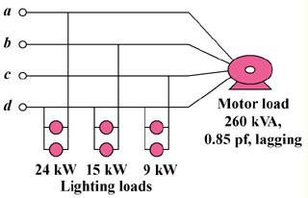

Figure 12.72
For Prob. 12.67.

